**System Description:** Written Description

Remote Checkout System

Amit Aalok

The remote checkout system is a modular system capable of authenticating an individual or entity against a remote data base and open authentication providing access to another entity and recording the whole process. The laptop checkout system secures laptops and allows the access of the laptop through a RFID authentication system.

The RCS has a built in RFID subsystem, and a security subsystem all running on an ESP 32 and has a secure connection to an remote SQL server.

When an entity or individual wants to access the laptops they scan their RFID device to the RFID scanner on the RCS, the security subsystem authenticates the RFID information against the remote database to see if this entity is allowed access. If the entity is allowed access then the security subsystem records this incident on the server and then sends back a access granted signal to the security subsystem, which then unlocks the laptops for a brief designated period of time allowing the individual to access the laptop.

If the individual’s RFID entity does not have the necessary access to the laptops saved on the server, the security subsystem does not allow access and records this unsuccess full attempt. After multiple failed attempts in a short period of time the system informs the assigned administrator through email via a SMTP sever.

**System Description:** Subsystems Flow Diagram

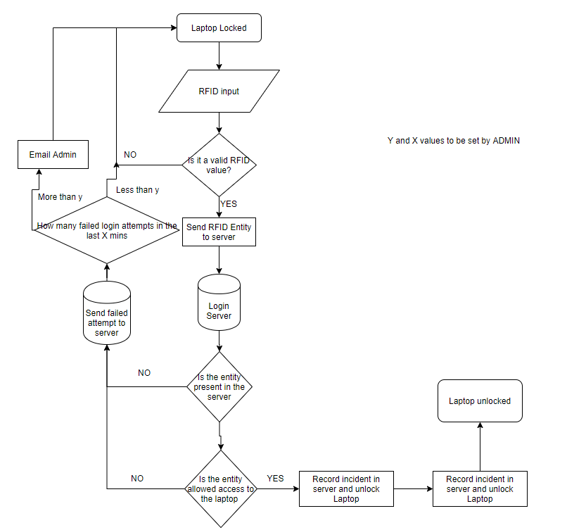

**System Description:** IPOC Diagram

IPOC Diagram:

INPUT

Electricity

Laptop locked/unlocked state info

RFID signal

OUTPUT

Unlock laptop via mechanical motion

Heat

PROCESS

Conversion of energy types

Send RFID entity to server

frf

fffffrrr

CONTROL

Is the RFID entity allowed to access the laptop?

What goes into the system. This includes energy, raw materials and data/information.

Includes what is expected of the system is to do or produce. Some outputs maybe undesirable in the form of waste energy.

Anything that can influence, modify or change the output result of the system.

FEEDBACK LOOP

VCE Systems Engineering

**System Description:** Subsystems Block Diagram

|  |
| --- |
| Individual  Database  RFID Scanner  A picture containing game, table  Description automatically generated  Laptop    ESP 32  Locking Mech |